BASIS launches its second

Sustainable Sports Awards

The Awards are open to any sports organisation in England, Wales, Scotland and Northern Ireland.

The Application Process

The application process is now open and will close on 30th September 2022. All applicants will be contacted by 21st October and successful entries will be invited to the Awards event in November 2022.

Winners and runner ups will also be offered the opportunity to present a case study on their project at future BASIS webinars, with relevant content will also added onto the BASIS website.

Awards will be given for the best sustainable initiatives that show innovation, impact and performance. Submissions are accepted both for an organisation as a whole, and for individuals within an organisation – with multiple submissions gladly received.

No project is too big or too small to be accepted for submission. What we’re really interested to hear about is how and why the initiative was conceived and what made it important to your particular organisation. We’d love to know what impacts the project has had – both on your organisation’s environmental impact and in terms of any wider positive influence (on the behaviour of any of your stakeholders such staff, suppliers, fans, etc., on setting an example to other clubs, and so on).

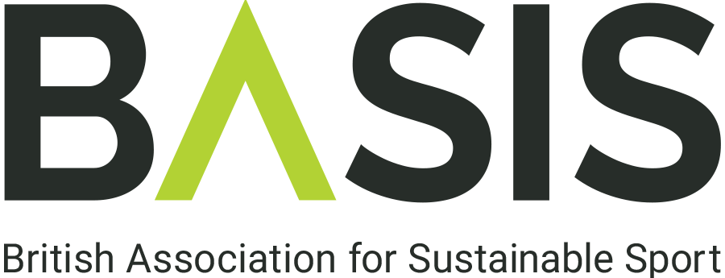

BASIS SUSTAINABLE SPORTS AWARDS 2022

The deadline for submission is: 5pm on 30th September 2022
We will be notifying winners on 21st October 2022

Please send your completed application to sally.cornelius@basis.org.uk

Title of project
Organisation

Nominee
Name of individual, if relevant

Contact | Email address:
 | Contact number:
 | Additional contact number (if relevant):
One paragraph overview of your nomination (maximum 100 words). A description including the purpose of the initiative, its start date and the current status.
How has the initiative has had a sustainable impact? (maximum 500 words)
Has the initiative in question proven results? Are those results outstanding and do they exceed targets; for example, in comparison to other similar initiatives by individuals, departments or organisations?

How has the initiative had a positive impact on sport? (maximum 500 words)
Has the organisation helped the reputation of sport as a platform for sustainability?

Application Submission

Please check this box if you do not wish your information to be used as case study material for future BASIS knowledge share events/publications. If used, all information will be attributed to the author organisation.

When submitting your nomination form, please provide a copy of your organisation’s logo and at least two images that can be used alongside your submission. Should you wish, you may also submit a short 5-minute video summarising your nomination, which we may share with other organisations as an example of best practice.

If you have any queries regarding the process, please do not hesitate to contact sally.cornelius@basis.org.uk

